FIRST 11 PROGRAMS ( D & B – METHOD )

1.Create a simple cloud software application for Flight Reservation System using any Cloud
Service Provider to demonstrate SaaS include the necessary fields such as one way, round
trip, From, to, Departure, Departure, Travelers &amp; Class, Fare Type, International and
Domestic Flights etc.
Aim
To create a cloud-based Flight Reservation System using Zoho Creator to demonstrate Software as a Service (SaaS).
Procedure
- Open Zoho Creator and create a new application named Flight Reservation System.
- Create a Flight Search form with trip type, departure, destination, and travel dates.
- Add fields for travelers, travel class, fare type, and domestic or international flights.
- Configure workflows to calculate the sample fare and save reservation details.
- Create booking reports, display confirmation status, and test the application.
Result
A cloud-based Flight Reservation System was designed using Zoho Creator to collect flight details, calculate sample fares, and manage reservation records, demonstrating the concept of SaaS.
Output
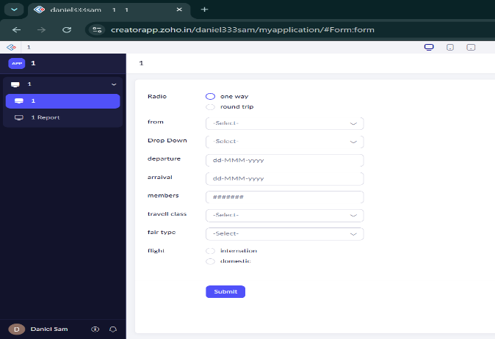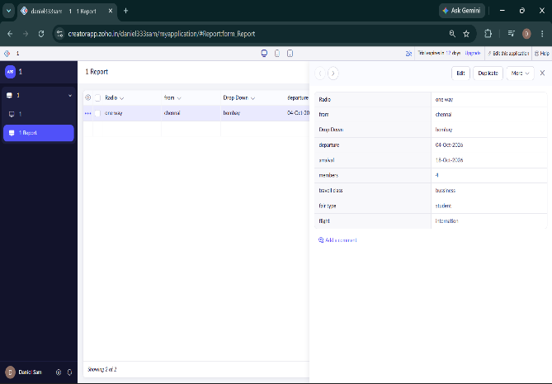

2.Create a simple cloud software application for Property Buying &amp; Rental process (In Chennai city) using any Cloud Service Provider to demonstrate SaaS include the necessary fields such as Buy, Rent, commercial, Rental Agreement , Rental Agreement, Area, place, Range ,property value etc.
Aim
To create a cloud-based Property Buying and Rental System for Chennai using Zoho Creator to demonstrate SaaS.
Procedure
- Create a new application named Property Buying and Rental System in Zoho Creator.
- Create a form with Buy/Rent and Residential/Commercial options.
- Add fields for area, location, price range, property value, and monthly rent.
- Include owner details, customer contact information, and rental agreement details.
- Create property reports, enter sample data, and test the application.
Result
A cloud-based Property Buying and Rental System was designed using Zoho Creator to manage property details, buying and rental options, prices, locations, and rental agreement information, demonstrating SaaS.
Output
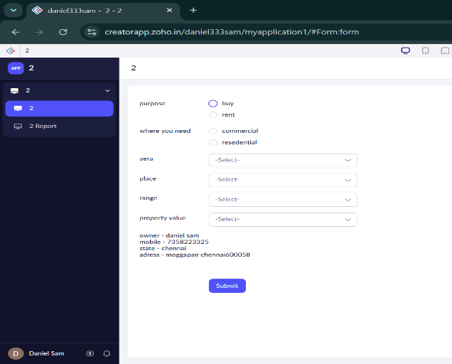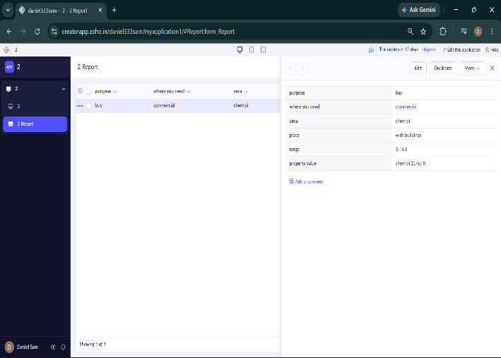

3.Create a simple cloud software application for Car Booking Reservation System using any
Cloud Service Provider to demonstrate SaaS include the necessary fields such as search for
cabs, from, to, rental , out station, Package type, hours/Days etc.
Aim
To create a cloud-based Car Booking Reservation System using Zoho Creator to demonstrate Software as a Service (SaaS).
Procedure
- Open Zoho Creator and create a new application named Car Booking Reservation System.
- Create a cab search form with From, To, Pickup Date, and Pickup Time fields.
- Add booking options such as Rental, Outstation, and Local.
- Include package type, number of hours/days, car type, passenger details, and estimated fare.
- Create booking reports, display reservation status, and test the application using sample bookings.
Result
A cloud-based Car Booking Reservation System was designed using Zoho Creator to manage cab searches, pickup and destination details, rental and outstation packages, booking duration, and reservation records, demonstrating SaaS.
Output
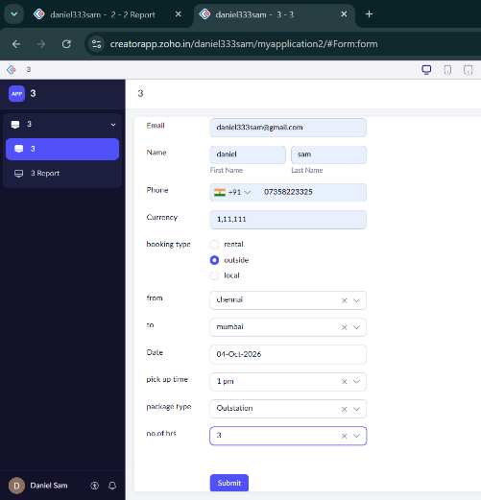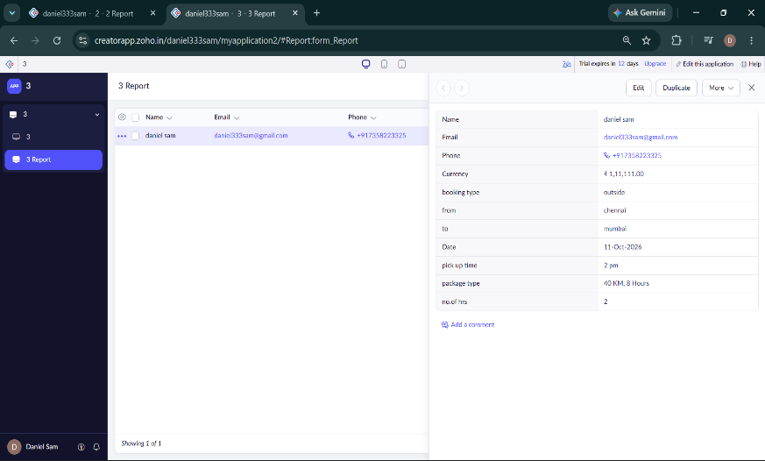

4.Create a simple cloud software application for Library book reservation system for SIMATS library using any Cloud Service Provider to demonstrate SaaS include the necessary fields such as Title of the book, author, publications, Year, edition, no of copies, Rack no, status(taken/returned) etc.
Aim
To create a cloud-based Library Book Reservation System for SIMATS Library using Zoho Creator to demonstrate Software as a Service (SaaS).
Procedure
- Open Zoho Creator and create a new application named SIMATS Library Book Reservation System.
- Create a book details form with Title, Author, Publication, Year, Edition, Number of Copies, and Rack Number.
- Add fields for Book ID, ISBN, Availability Status, and Taken/Returned status.
- Create a reservation form with Student Name, Register Number, Book Title, Issue Date, and Return Date.
- Generate reports to manage book availability and reservations, then test the application using sample data.
Result
A cloud-based SIMATS Library Book Reservation System was designed using Zoho Creator to manage book details, rack locations, available copies, and book reservation and return records, demonstrating SaaS.
Output
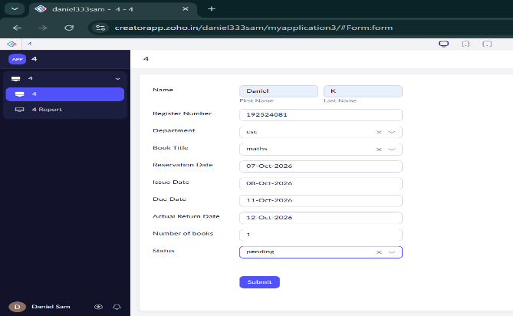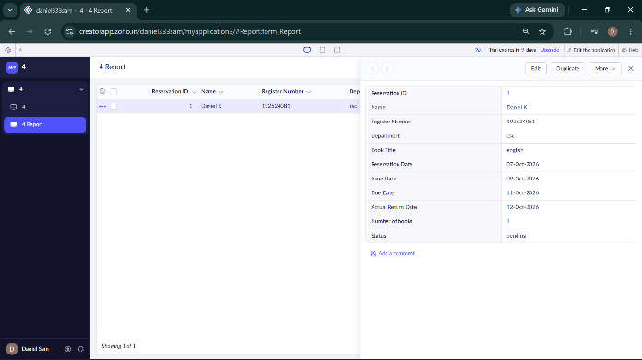

5.Create a simple cloud software application for Mark Sheet Processing System using any
Cloud Service Provider to demonstrate SaaS include the necessary fields such as name of
the student, Reg no of the student , Subjects , Marks, Average, percentage, rank, overall
performance etc.
Aim
To create a simple cloud-based Mark Sheet Processing System using Zoho Creator to demonstrate Software as a Service (SaaS).
Procedure
- Create a new Zoho Creator application named Mark Sheet Processing System.
- Create a form with Student Name, Register Number, and Subject Names.
- Add fields for Marks, Total Marks, Average, and Percentage.
- Add fields for Rank and Overall Performance based on the student's marks.
- Create reports to display student mark sheets and test the application using sample data.
Result
A cloud-based Mark Sheet Processing System was created using Zoho Creator to manage student details, marks, average, percentage, rank, and overall performance, successfully demonstrating SaaS.
Output
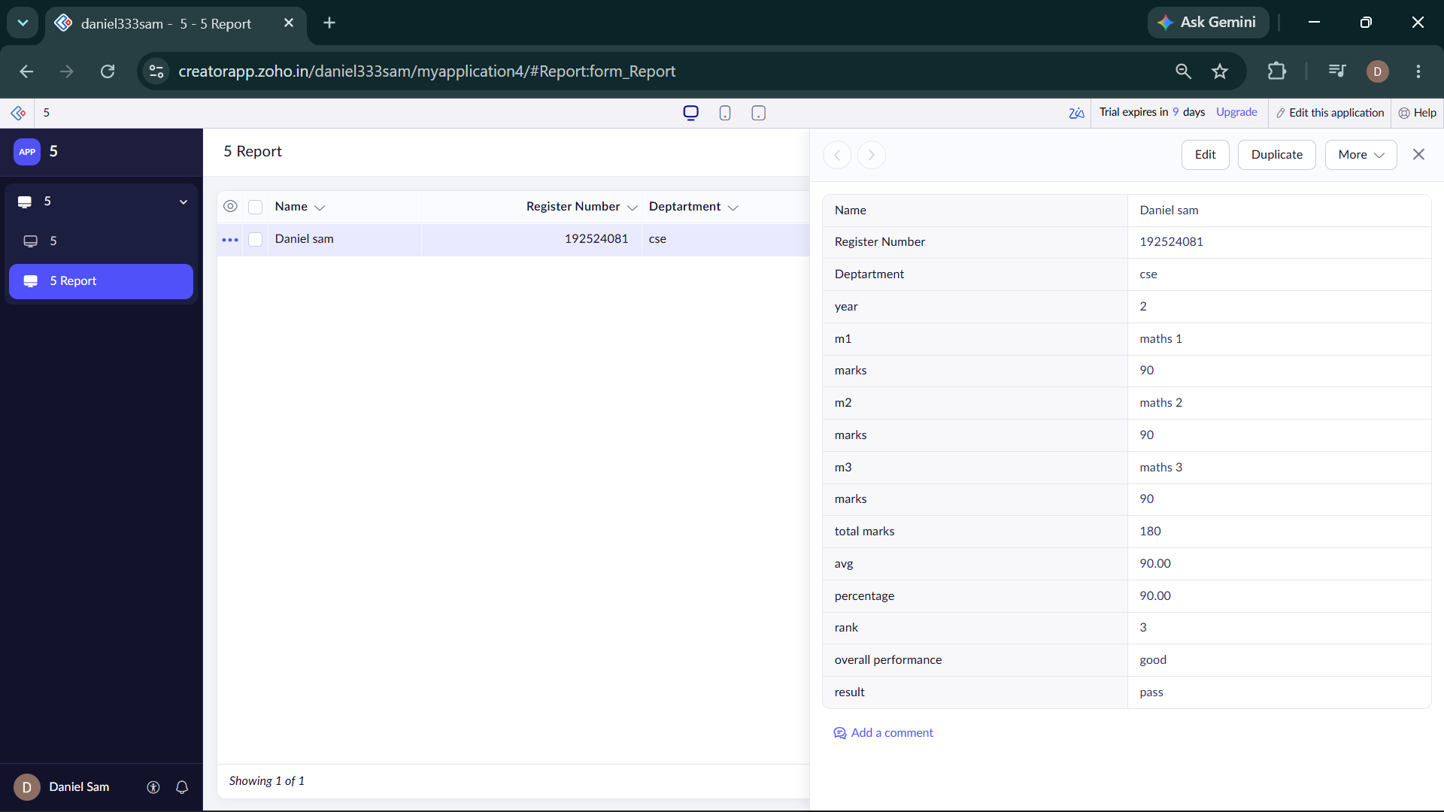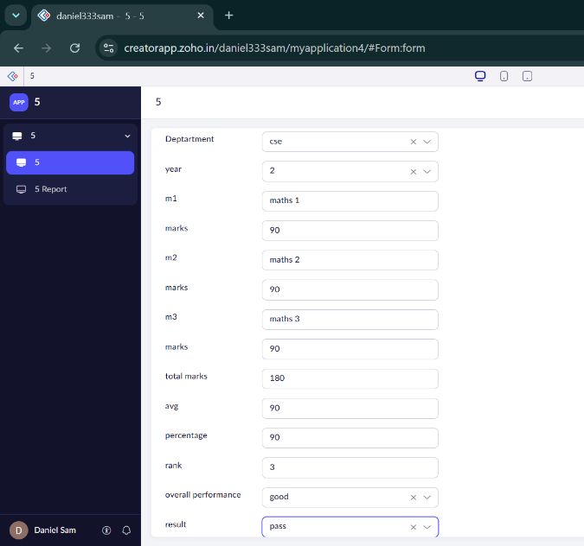

6.Create a simple cloud software application for Payroll Processing System using any Cloud
Service Provider to demonstrate SaaS include the necessary fields such as Name of the
employee, experience in present org , over all experience, basic pay, HRA, DA, TA, net pay,
gross pay etc.
Aim
To create a simple cloud-based Payroll Processing System using Zoho Creator to demonstrate Software as a Service (SaaS).
Procedure
- Create a new Zoho Creator application named Payroll Processing System.
- Create an employee form with Employee Name, Employee ID, Department, Present Organization Experience, and Overall Experience.
- Add salary fields such as Basic Pay, HRA, DA, TA, and deductions.
- Configure workflows to automatically calculate Gross Pay and Net Pay.
- Create payroll reports to display employee salary details and test the system using sample employee data.
Result
A cloud-based Payroll Processing System was created using Zoho Creator to manage employee details, experience, salary components, gross pay, deductions, and net pay, successfully demonstrating SaaS.
Output
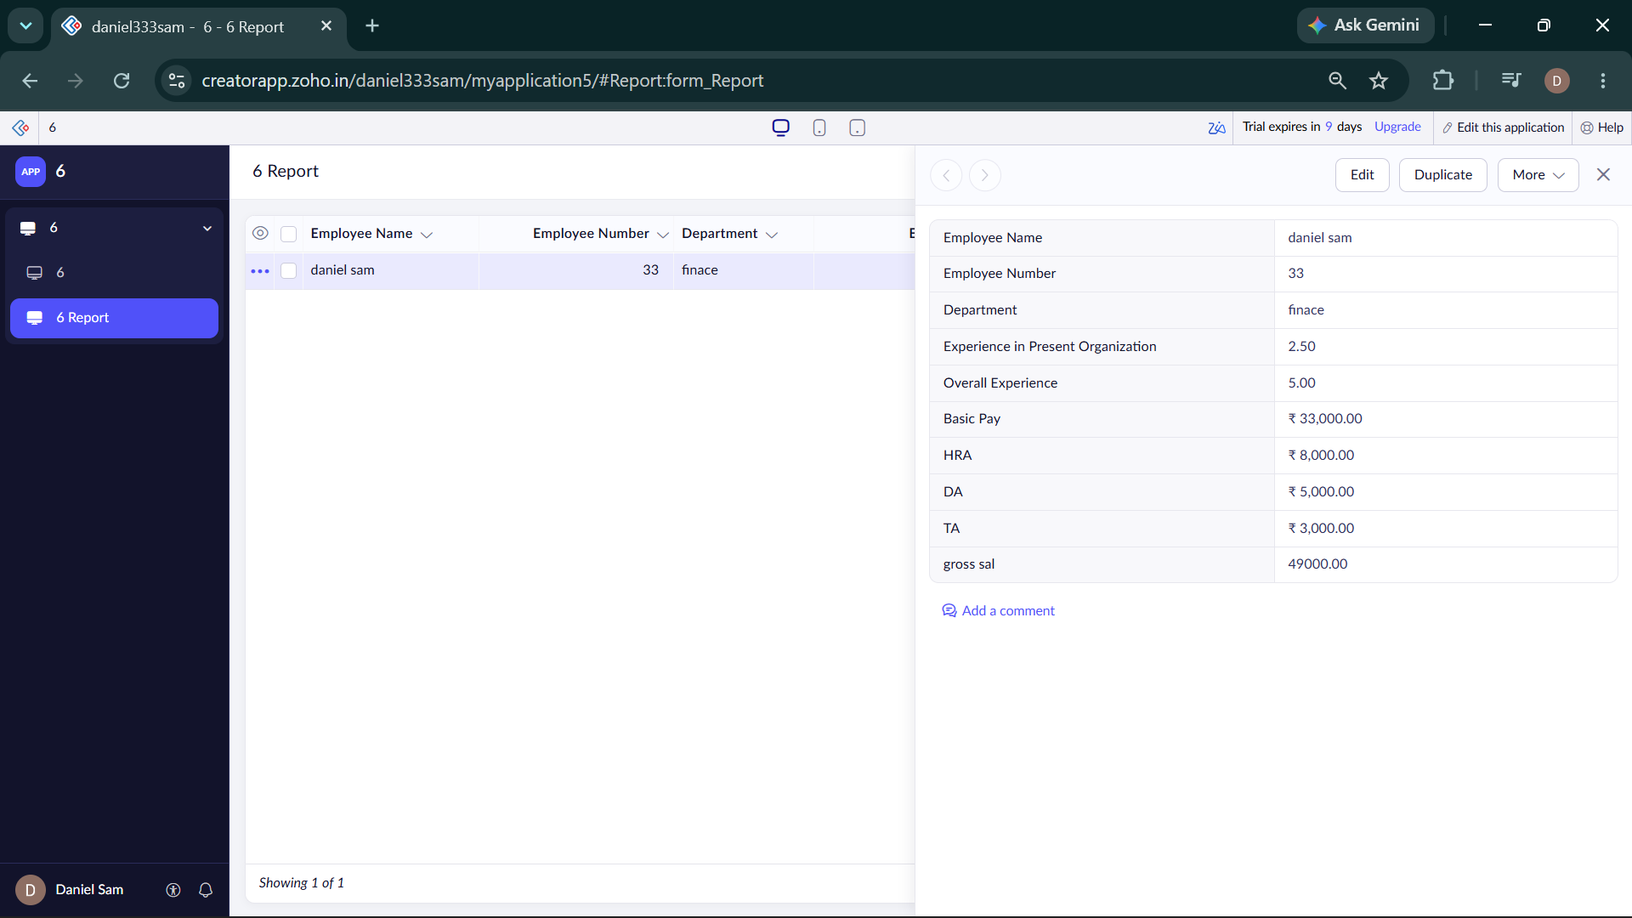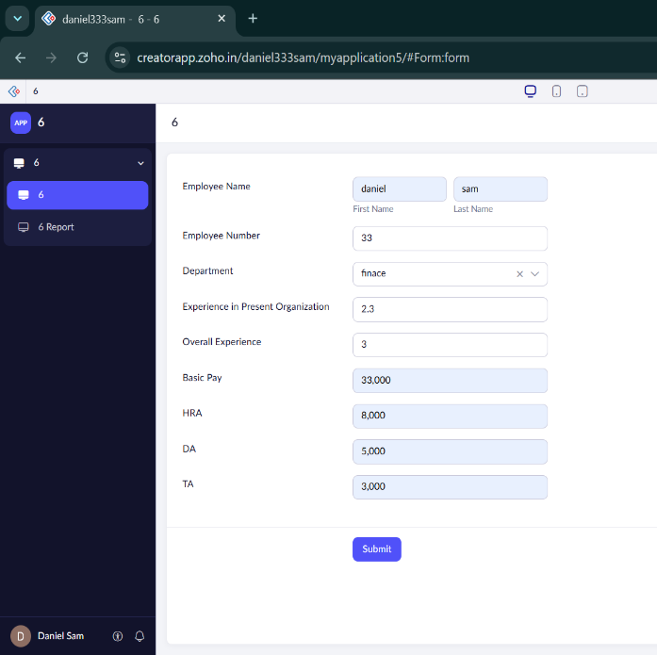

7. Create a simple cloud software application for Students Attendance System using any Cloud Service Provider to demonstrate SaaS include the necessary fields such as name of the students, course, present , Absent, course attendance, OD request, grade, attendance percentage, etc.
Aim
To create a simple cloud-based Students Attendance System using Zoho Creator to demonstrate Software as a Service (SaaS).
Procedure
- Create a new Zoho Creator application named Students Attendance System.
- Create a form with Student Name, Register Number, Course, and Attendance Date.
- Add fields to record Present, Absent, and OD Request.
- Configure automatic calculation of Attendance Percentage and assign the attendance grade.
- Create reports to view student attendance and test the system using sample data.
Result
A cloud-based Students Attendance System was created using Zoho Creator to manage student details, course attendance, present/absent status, OD requests, attendance percentage, and grades, demonstrating SaaS.
Output
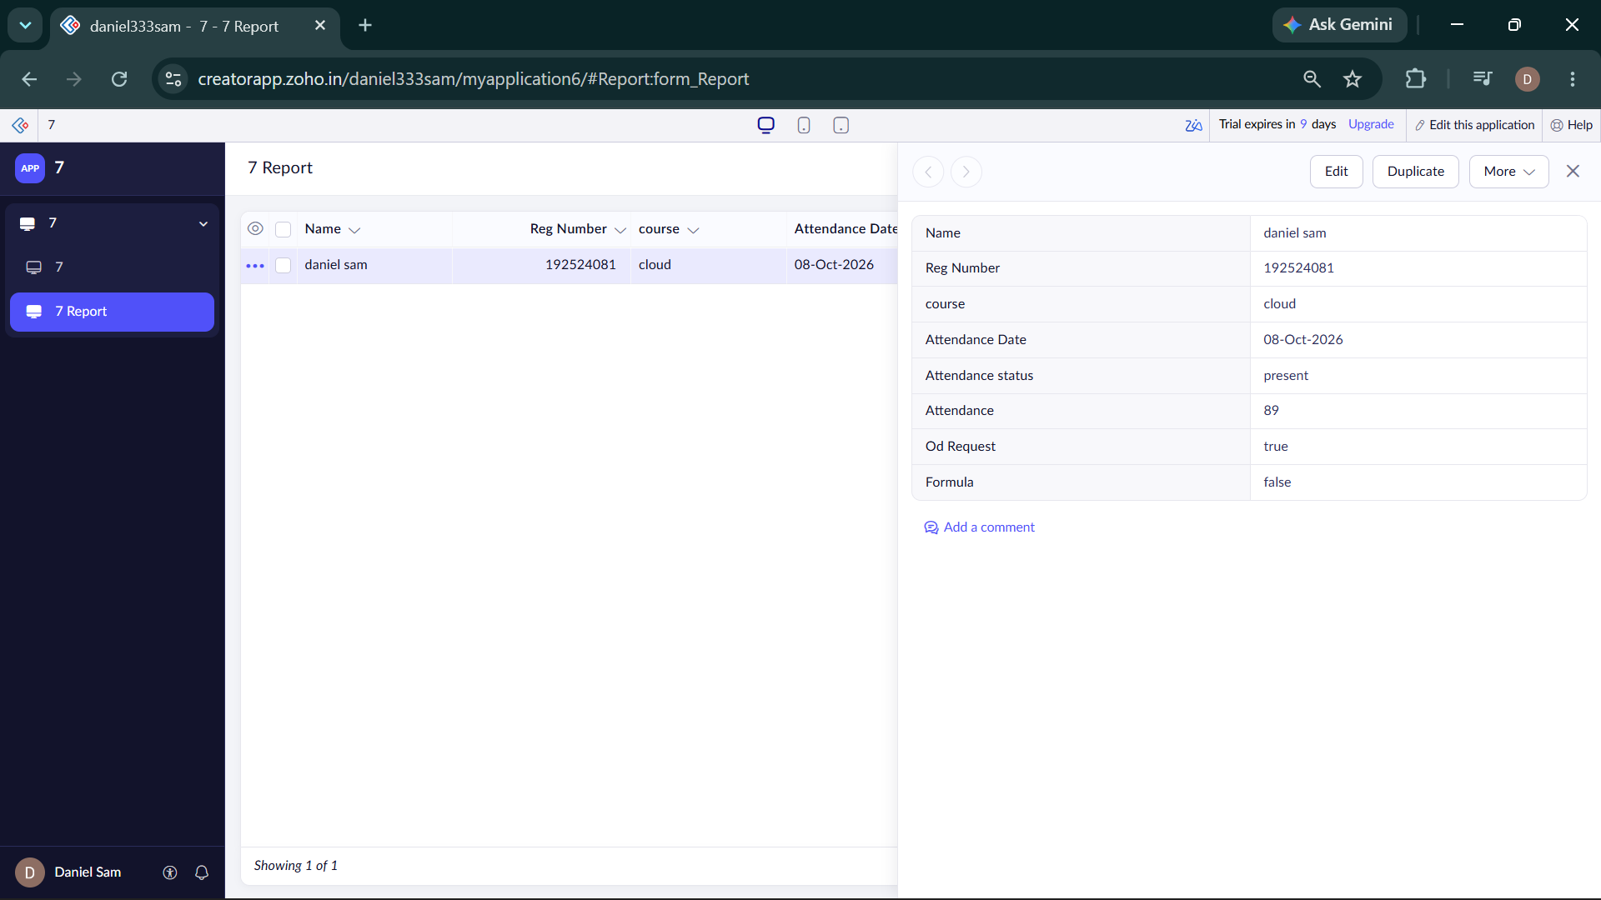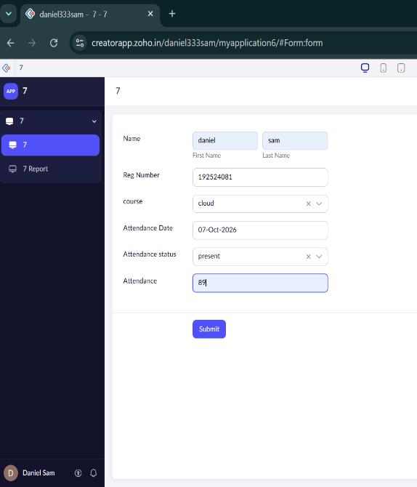

8. Create a simple cloud web application for student counselling system using any CloudService Provider to demonstrate SaaS with the fields of student name, age, address, phone, subjects studied, Year of passing, percentage of marks, domain interest, etc.
Aim
To create a simple cloud-based Student Counselling System using Zoho Creator to demonstrate Software as a Service (SaaS).
Procedure
- Create a new Zoho Creator application named Student Counselling System.
- Create a student form with Student Name, Age, Address, and Phone Number.
- Add fields for Subjects Studied, Year of Passing, and Percentage of Marks.
- Add fields for Domain Interest and Counselling Remarks.
- Create reports to view student details and counselling information and test the application with sample data.
Result
A cloud-based Student Counselling System was created using Zoho Creator to manage student details, academic information, domain interests, and counselling records, demonstrating SaaS.
Output
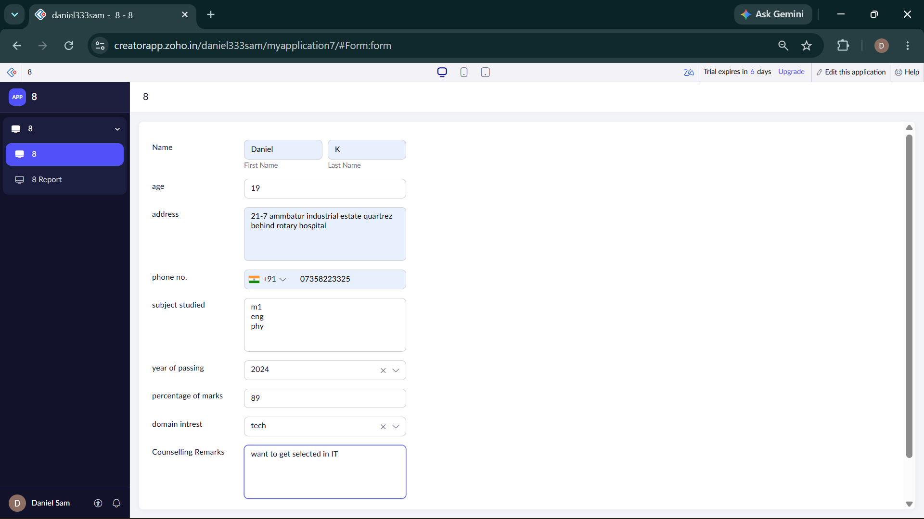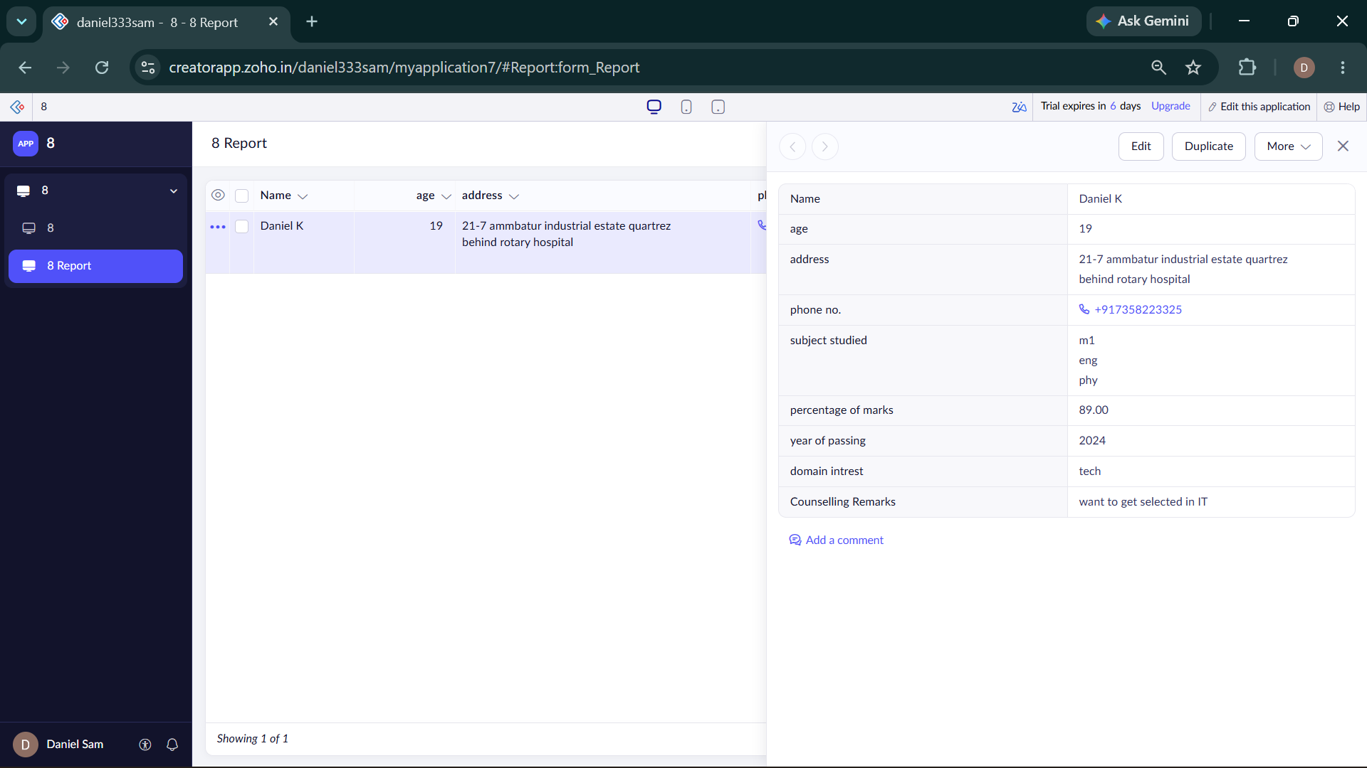

9.Create a simple cloud software application for Hospital information system for SIMATS Hospital using any Cloud Service Provider to demonstrate SaaS with fields of patient name,age, address, phone, email, Attender name, attender phone, doctor name, diseases, etc.
Aim
To create a simple cloud-based Hospital Information System for SIMATS Hospital using Zoho Creator to demonstrate Software as a Service (SaaS).
Procedure
- Create a new Zoho Creator application named SIMATS Hospital Information System.
- Create a patient form with Patient Name, Age, Gender, Address, Phone Number, and Email.
- Add fields for Attender Name, Attender Phone, Doctor Name, and Department.
- Add fields for Disease, Appointment Date, and Patient Status.
- Create reports to manage patient details and appointments, and test the application using sample data.
Result
A cloud-based SIMATS Hospital Information System was designed using Zoho Creator to manage patient information, attender details, doctor information, diseases, and appointments, demonstrating SaaS.
Output
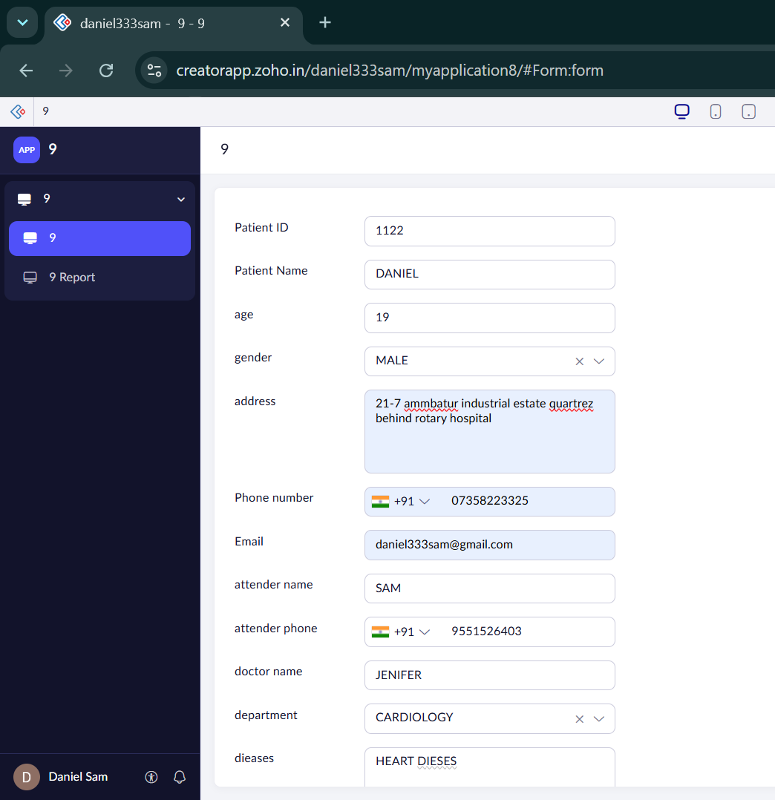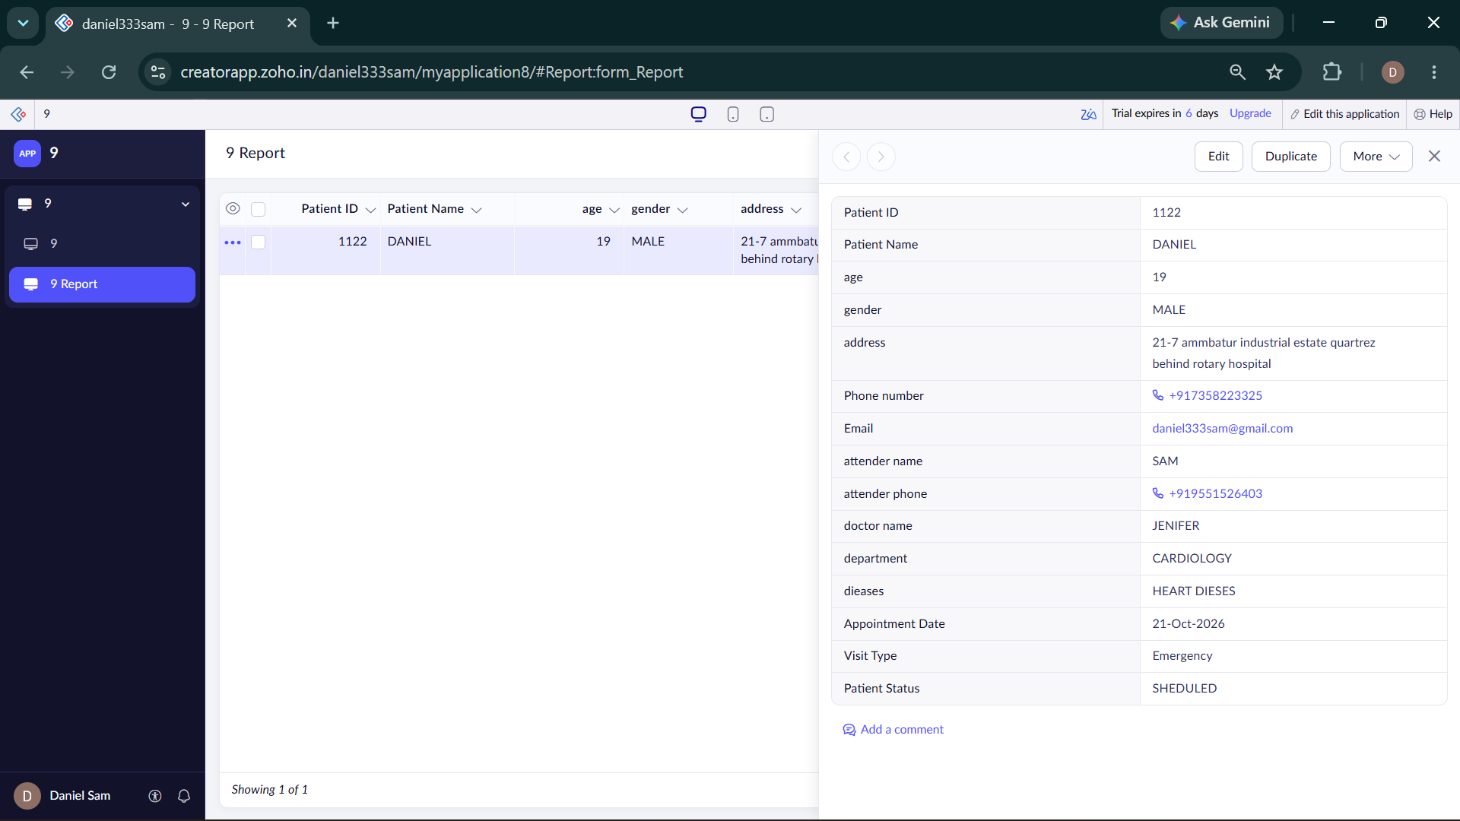
10. Create a simple cloud software application to run a c program to display the student information using any Cloud Service Provider to demonstrate SaaS with the template of student name, reg no, address, phone, age, courses, grades and attendance report, progress report, Semester mark sheet forms
Aim
To create a cloud-based Student Information System using Zoho Creator to demonstrate Software as a Service (SaaS), managing student details, grades, attendance, progress reports, and semester mark sheets.
Procedure
- Create a new application in Zoho Creator named Student Information System.
- Create a Student Information form with student name, register number, address, phone, age, and course.
- Create separate forms for Grades, Attendance Report, Progress Report, and Semester Mark Sheet.
- Add the required fields and dropdown options to each form.
- Create reports to view and manage student records, and test the application using sample data.
Result
A cloud-based Student Information System was designed using Zoho Creator to manage student details, grades, attendance, progress reports, and semester mark sheets, demonstrating the SaaS model.
Output
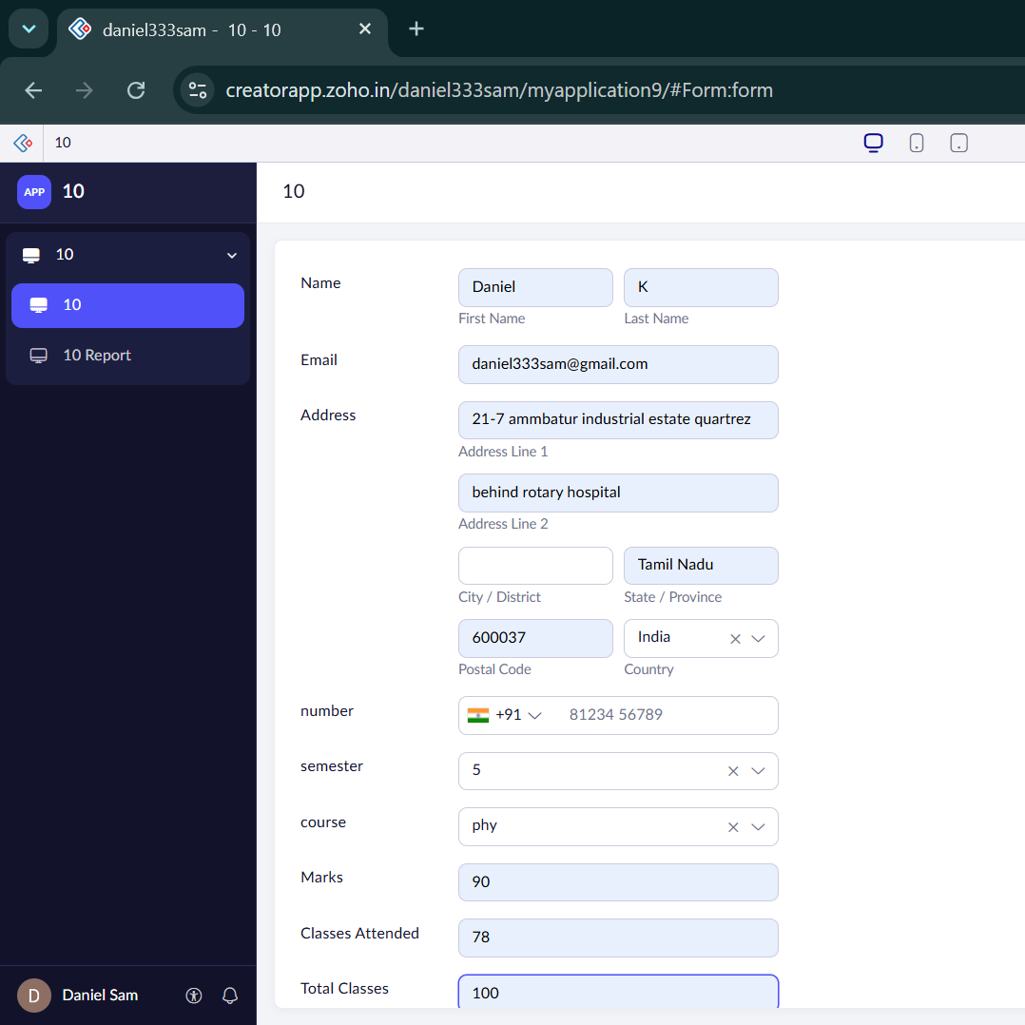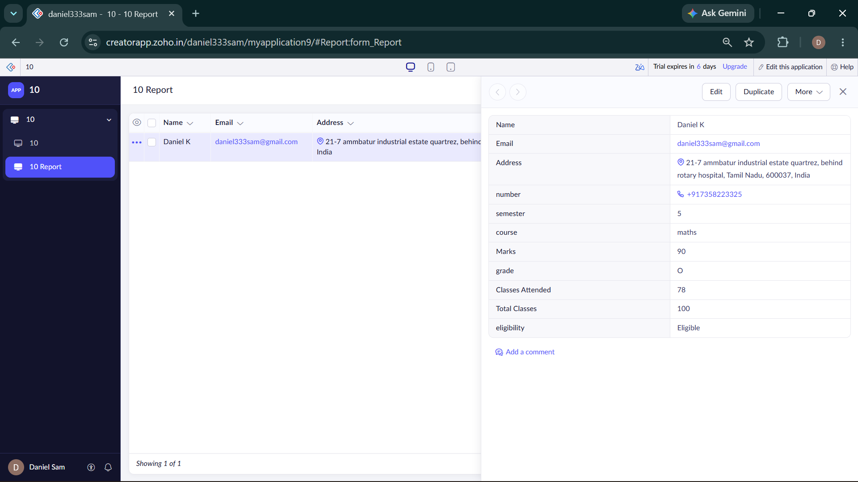

11. Create a simple cloud software application for online super market using any Cloud Service Provider to demonstrate SaaS with the template of customer name, address, phone, email, items, quantity etc. with the item classification form.
Aim
To create a cloud-based Online Supermarket application using Zoho Creator to demonstrate Software as a Service (SaaS) for managing customer details, orders, and item classifications.
Procedure
- Create a new application in Zoho Creator named Online Supermarket.
- Create a Customer Order form with customer name, address, phone, email, item name, and quantity.
- Create an Item Classification form with item name, category, price, and available stock.
- Add suitable item categories and configure the total amount calculation.
- Create reports to view customer orders and item details, and test the application using sample data.
Result
A cloud-based Online Supermarket application was designed using Zoho Creator to manage customer information, orders, quantities, prices, and item classifications, demonstrating the SaaS model.
Output
